**INVERTING AND NON-INVERTING AMPLIFIER USING OP-AMP**

AIM:

1. Design an Inverting and Non Inverting Amplifier using Op Amp using F/B network.
2. Determine the Bandwidth of Amplifier using AC analysis.
3. Evaluate the open loop gain, loop gain and close loop gain of both the amplifier (*VFB/VTEST*) and do AC analysis.
4. Comment on the stability of the Feedback Amplifier.

APPARATUS REQUIRED:

LTSpice Software.

THEORY:

An inverting amplifier (also known as an inverting operational amplifier or an inverting op-amp) is a type of [operational amplifier](https://www.electrical4u.com/op-amp-working-principle-of-op-amp/) circuit which produces an output which is out of phase with respect to its input by 180o. The voltage gain of the inverting amplifier is,

Av =

Feedback control of the non-inverting operational amplifier is achieved by applying a small part of the output voltage signal back to the inverting ( – ) input terminal via a Rƒ – R2 voltage divider network, again producing negative feedback. This closed-loop configuration produces a non-inverting amplifier circuit with very good stability, a very high input impedance, Rin approaching infinity, as no current flows into the positive input terminal, (ideal conditions) and a low output impedance. The voltage gain of the non inverting amplifier is,

Av = 1 + $\frac{Rf}{R1}$

INVERTING AMPLIFIER:

OPEN LOOP

CIRCUIT:

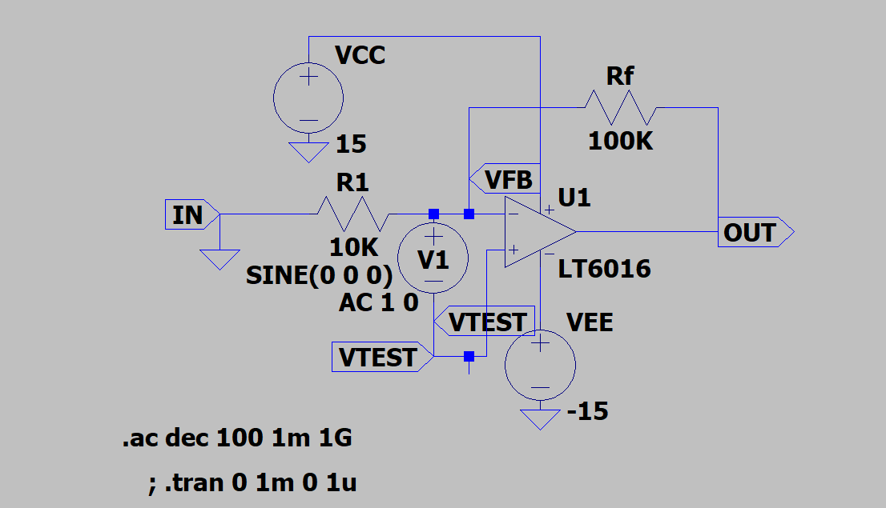

OUTPUT:

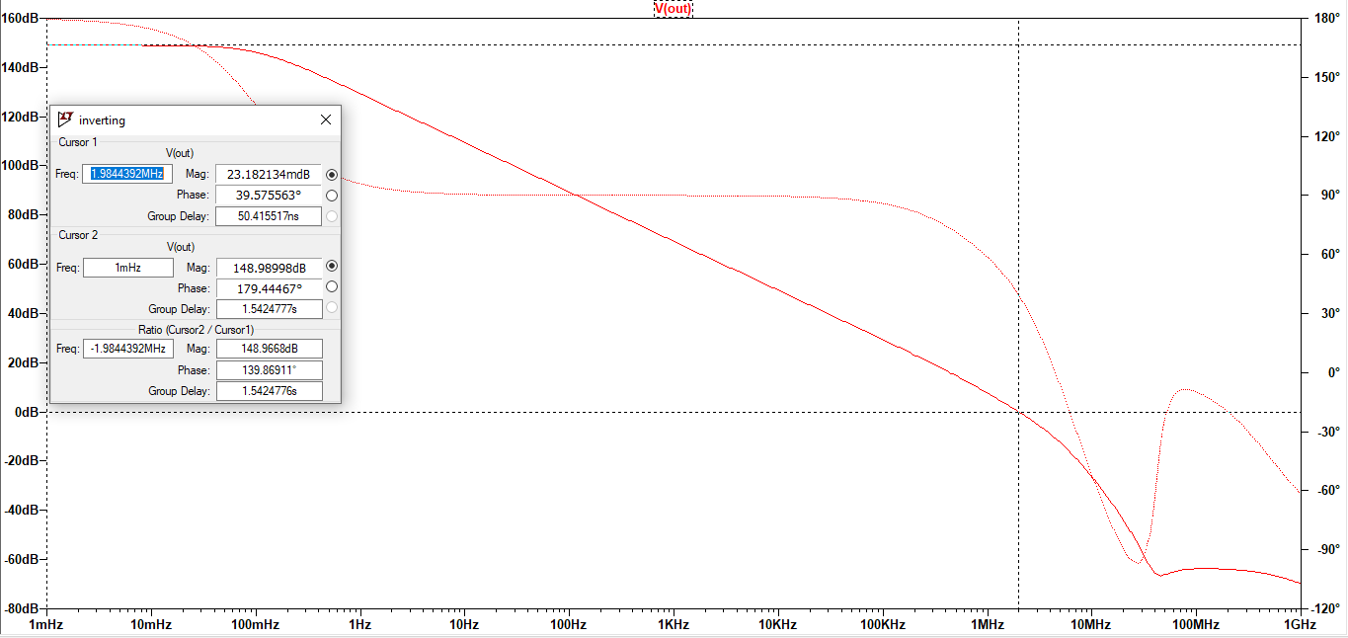

Vfb / VTest

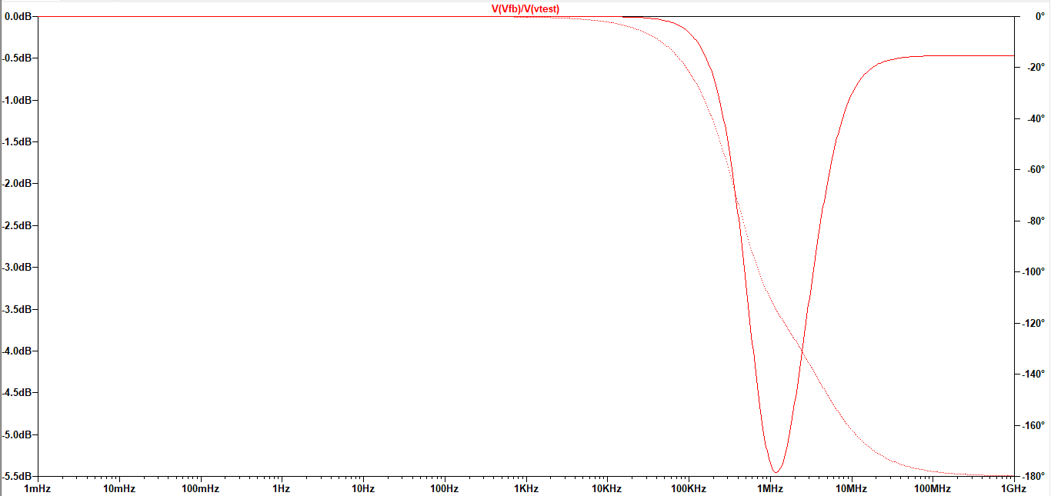

CLOSED LOOP:

CIRCUIT:

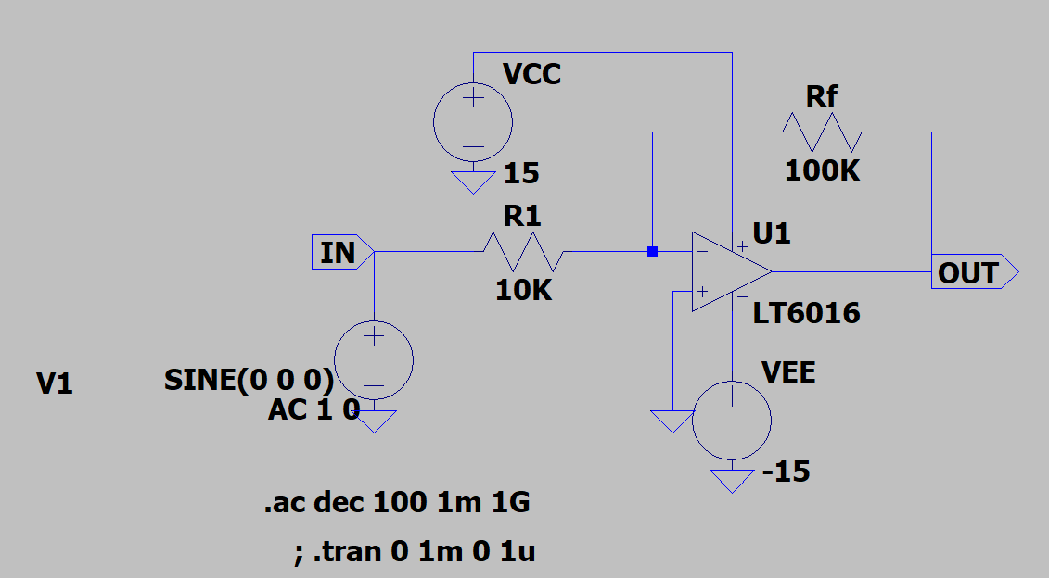

OUTPUT:

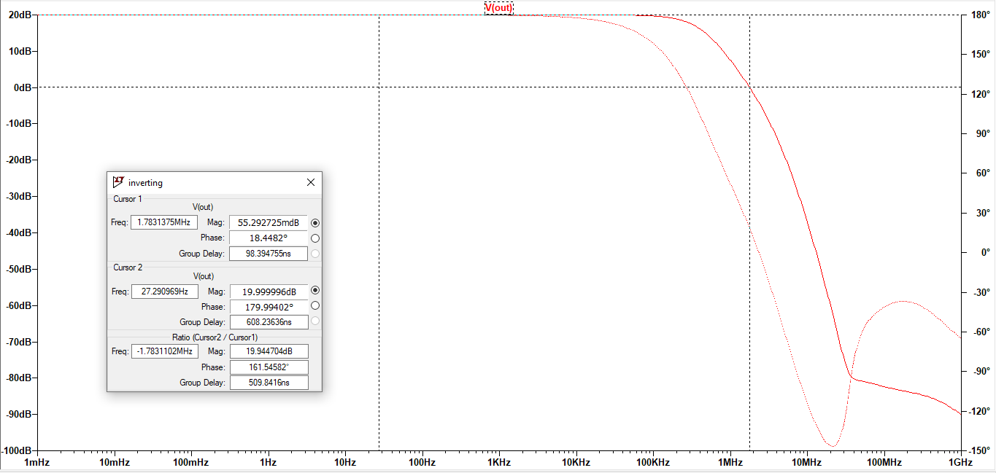

TRANSIENT:

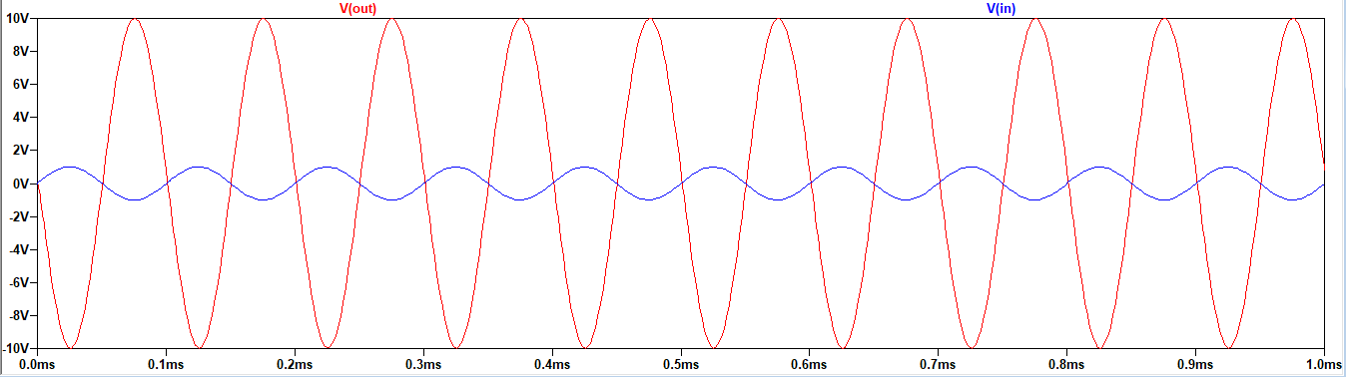

Observation:

Open loop: Wgc = 1.984MHz. The phase doesn’t cross -180 degrees so the system is stable.

Closed loop: Wgc = 1.784MHz. The phase doesn’t cross -180 degrees so the system is stable.  
Closed loop gain = 10

NON INVERTING AMPLIFIER:

OPEN LOOP

CIRCUIT:

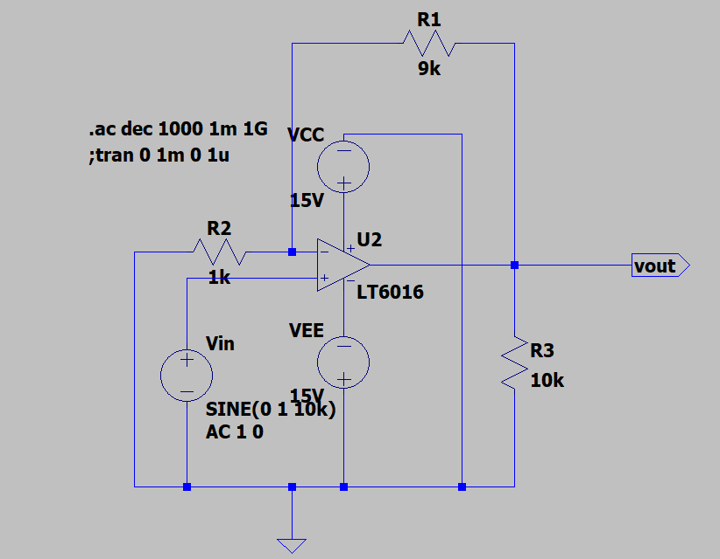

OUTPUT:

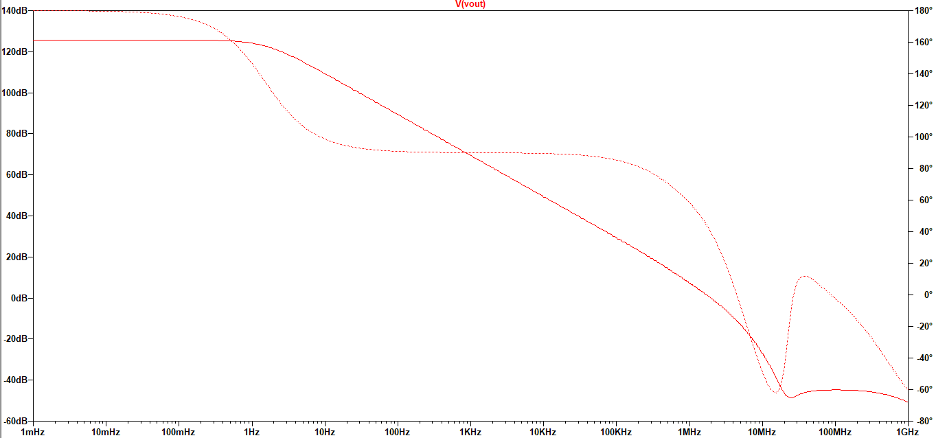

Vfb / VTest

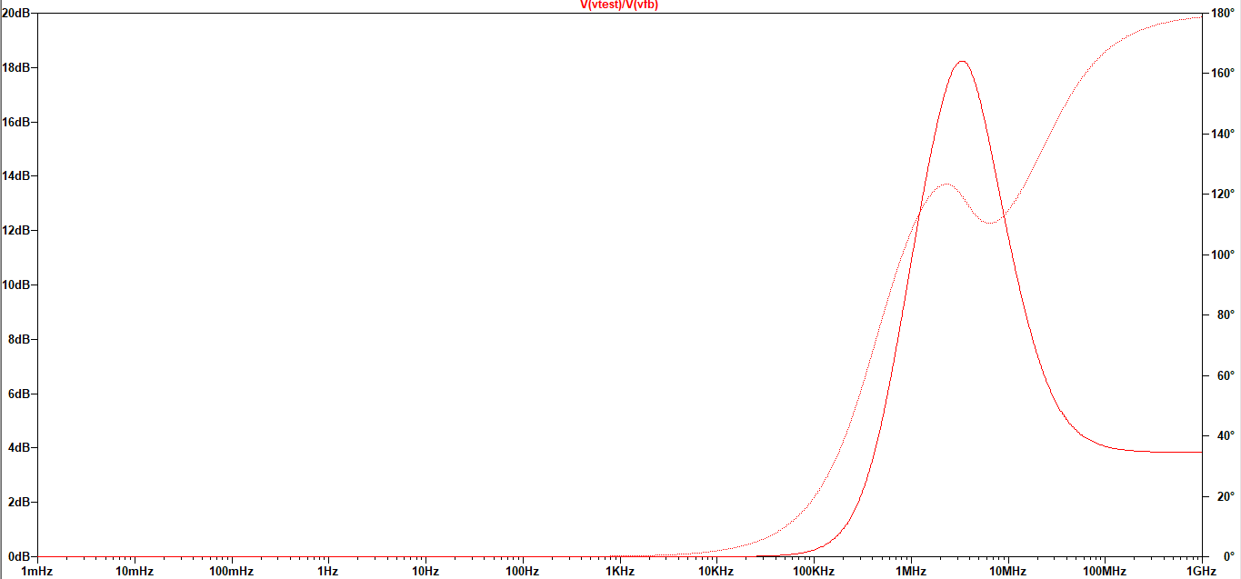

CLOSED LOOP:

CIRCUIT:



OUTPUT:

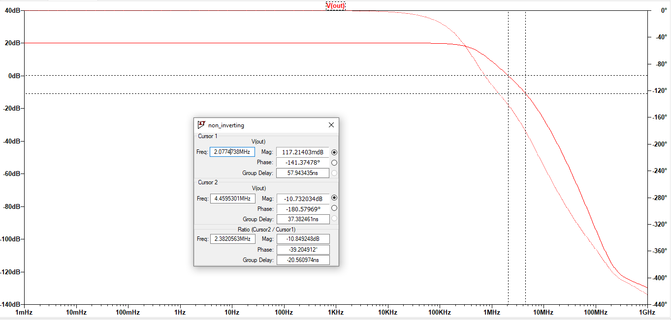

TRANSIENT:

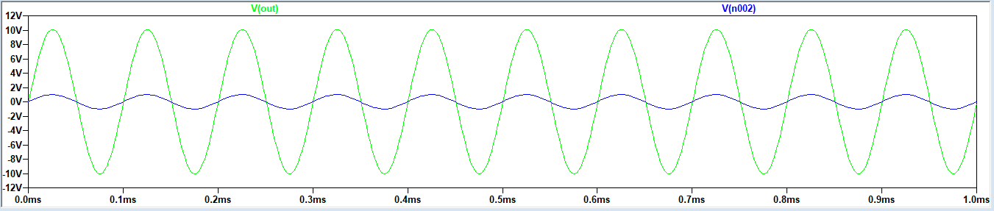

Observation:

Open loop: Open loop: Wgc = 1.984MHz. The phase doesn’t cross -180 degrees so the system is stable.

Closed loop: Wgc = 2.07 MHz, Wpc = 4.45 MHz. Wgc < Wpc, so the system is stable.

Phase Margin = -39.2 degrees Gain Margin = 10dB  
Closed loop gain = 10

**Result:**

The Experiment has been performed with both configuration of OpAmp and found to be correct.